Name: Moses Muamba-Nzambi & Justin Albecker
Course: CST-350
Assignment: Milestone 2
Date: June 14, 2026
Instructor: Abhishek Jain

Screencast -
Github - https://github.com/MosesMNZ/CST-350-Milestone-2

CST-350 Milestone 2 - Minesweeper User Interface
Student: Moses Muamba-Nzambi

Overview

For Milestone 2, we continued developing our Minesweeper web application using ASP.NET Core MVC. The focus of this milestone was to build the user interface for the game, including the Start Game page, the MineSweeper game board, and pages for displaying the game outcome. We also continued using session management from Milestone 1 to restrict access to authenticated users. The frontend was designed to work with the backend game logic, providing a complete Minesweeper gameplay experience.

Start Game Page

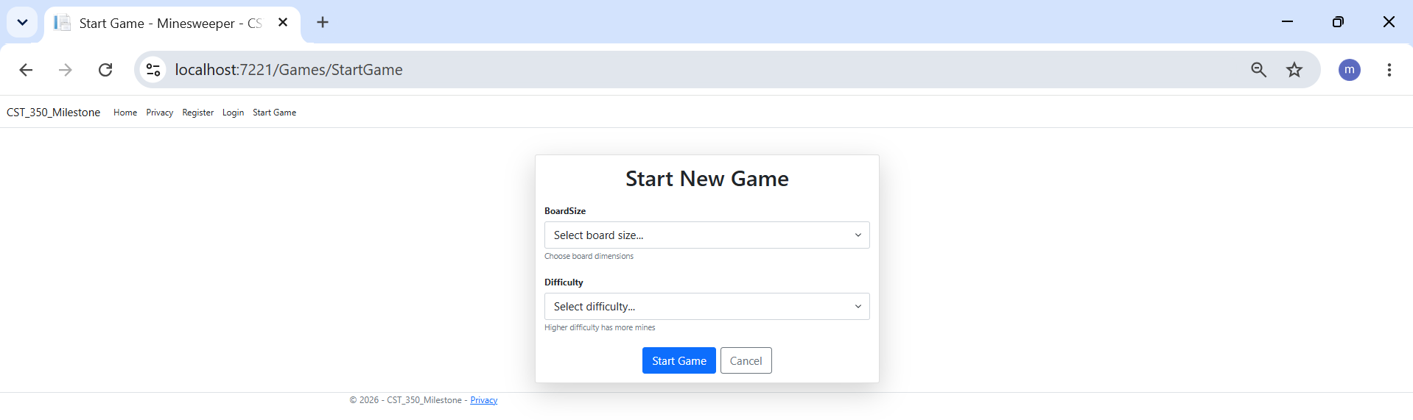
Figure 1. Start Game page where the user selects the board size and difficulty level before beginning a new Minesweeper game.

We created a Start Game page that allows users to configure a new game before playing. Users can choose the board size and difficulty level using dropdown lists. Server-side validation ensures that both options are selected before the game can begin.

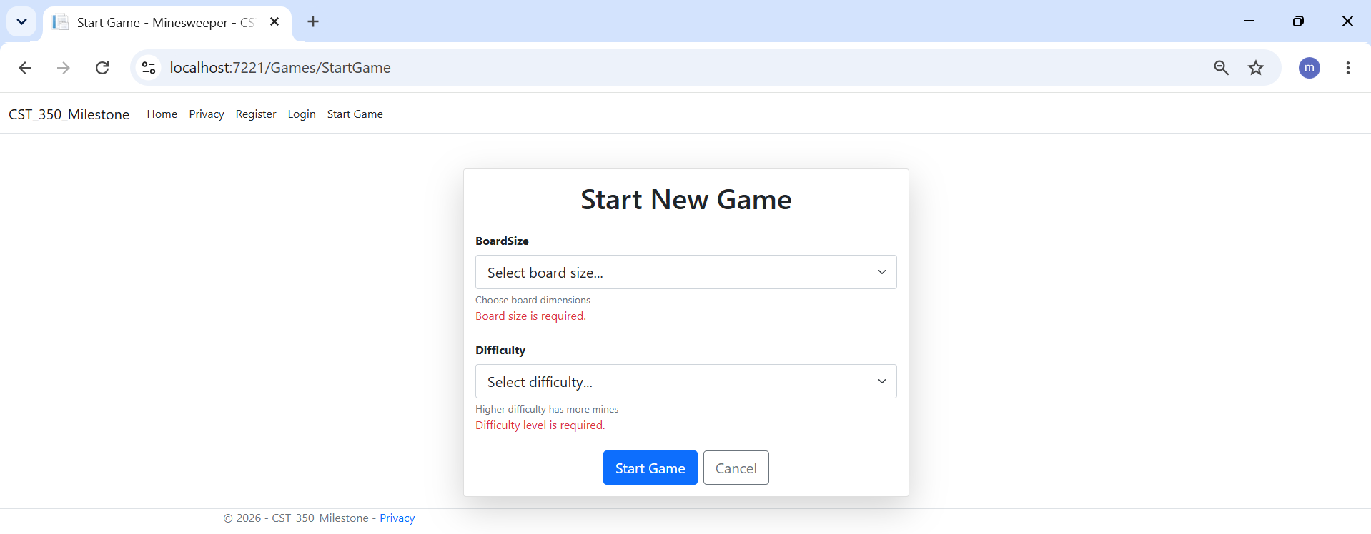
Figure 2. Validation messages displayed when the user attempts to start a game without selecting the required options.

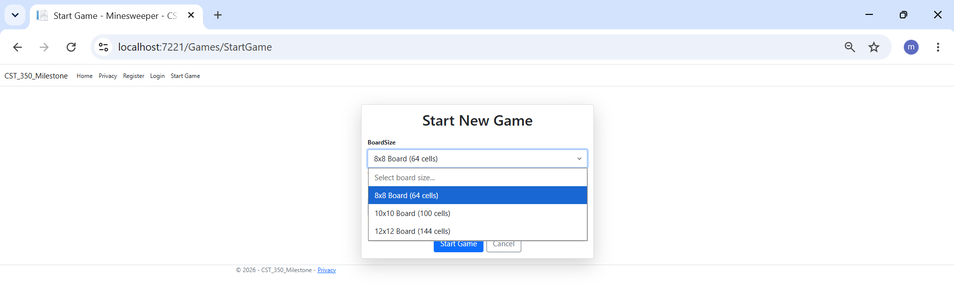
Figure 3. Board size dropdown showing the available game board sizes (8×8, 10×10, and 12×12).

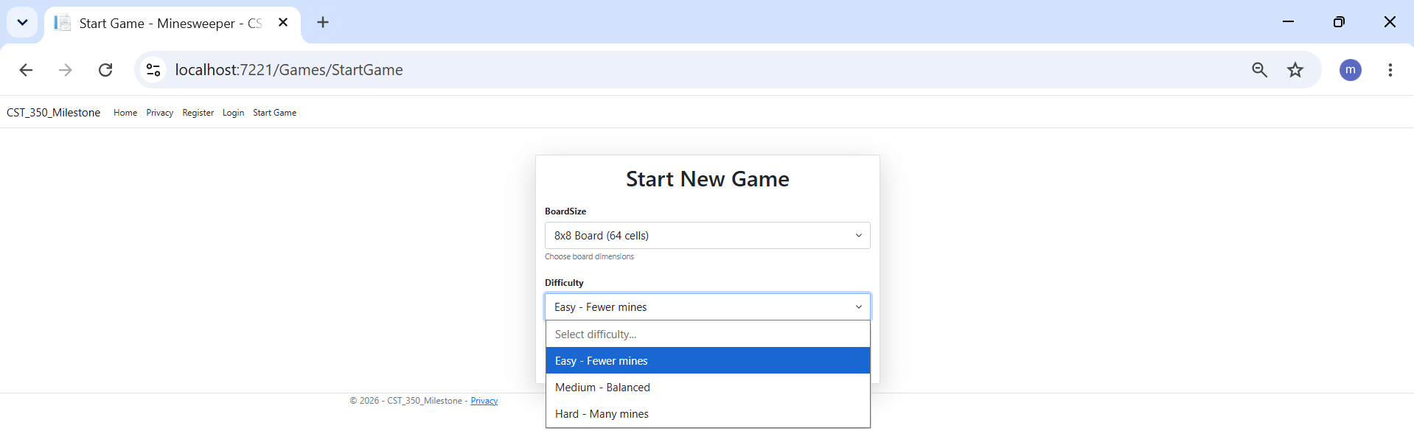
Figure 4. Difficulty dropdown showing the available difficulty levels (Easy, Medium, and Hard).

MineSweeper Game Board

After the user selects the game settings, the application displays the MineSweeper game board. The board is generated dynamically based on the selected board size, allowing the application to display different grid sizes such as 8×8, 10×10, or 12×12. Each cell is represented by a CellModel, following the same approach used in the ButtonGrid activity. The frontend displays the game board while the backend game logic manages mine placement, cell selection, and game progress.

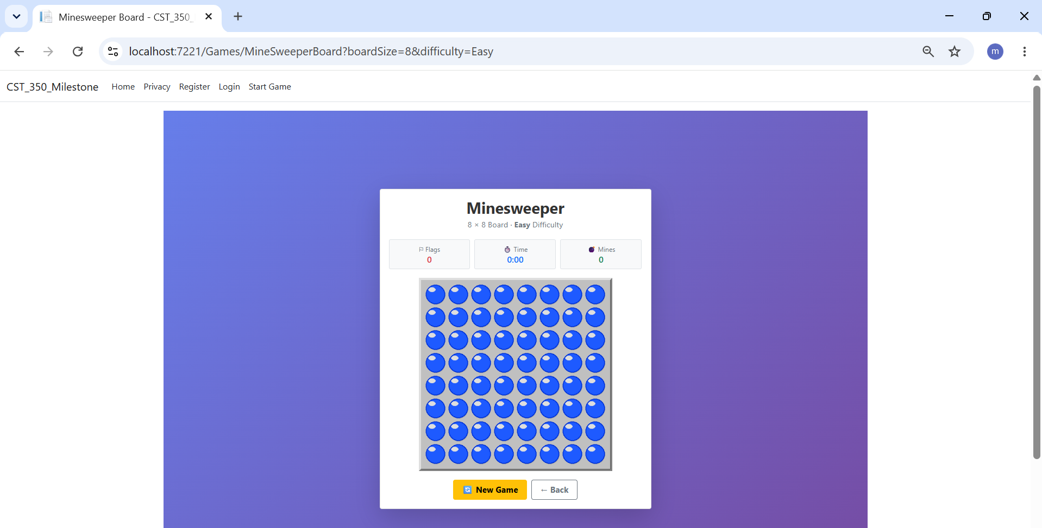
Figure 5. MineSweeper game board generated for an 8×8 game using placeholder cells.

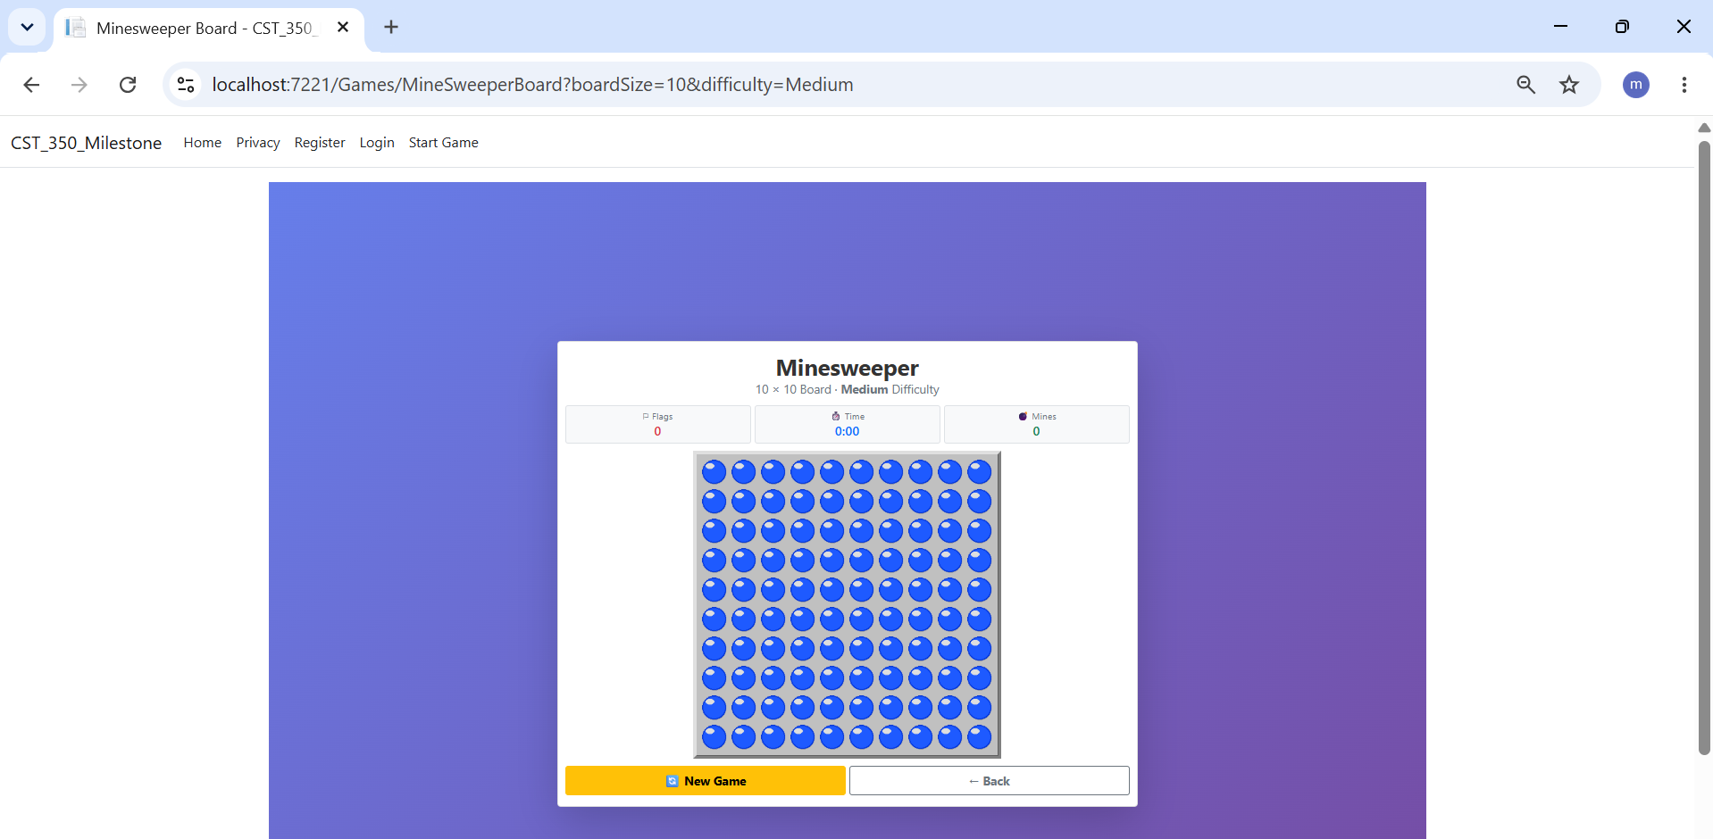
Figure 6. MineSweeper game board generated dynamically for a 10×10 board.

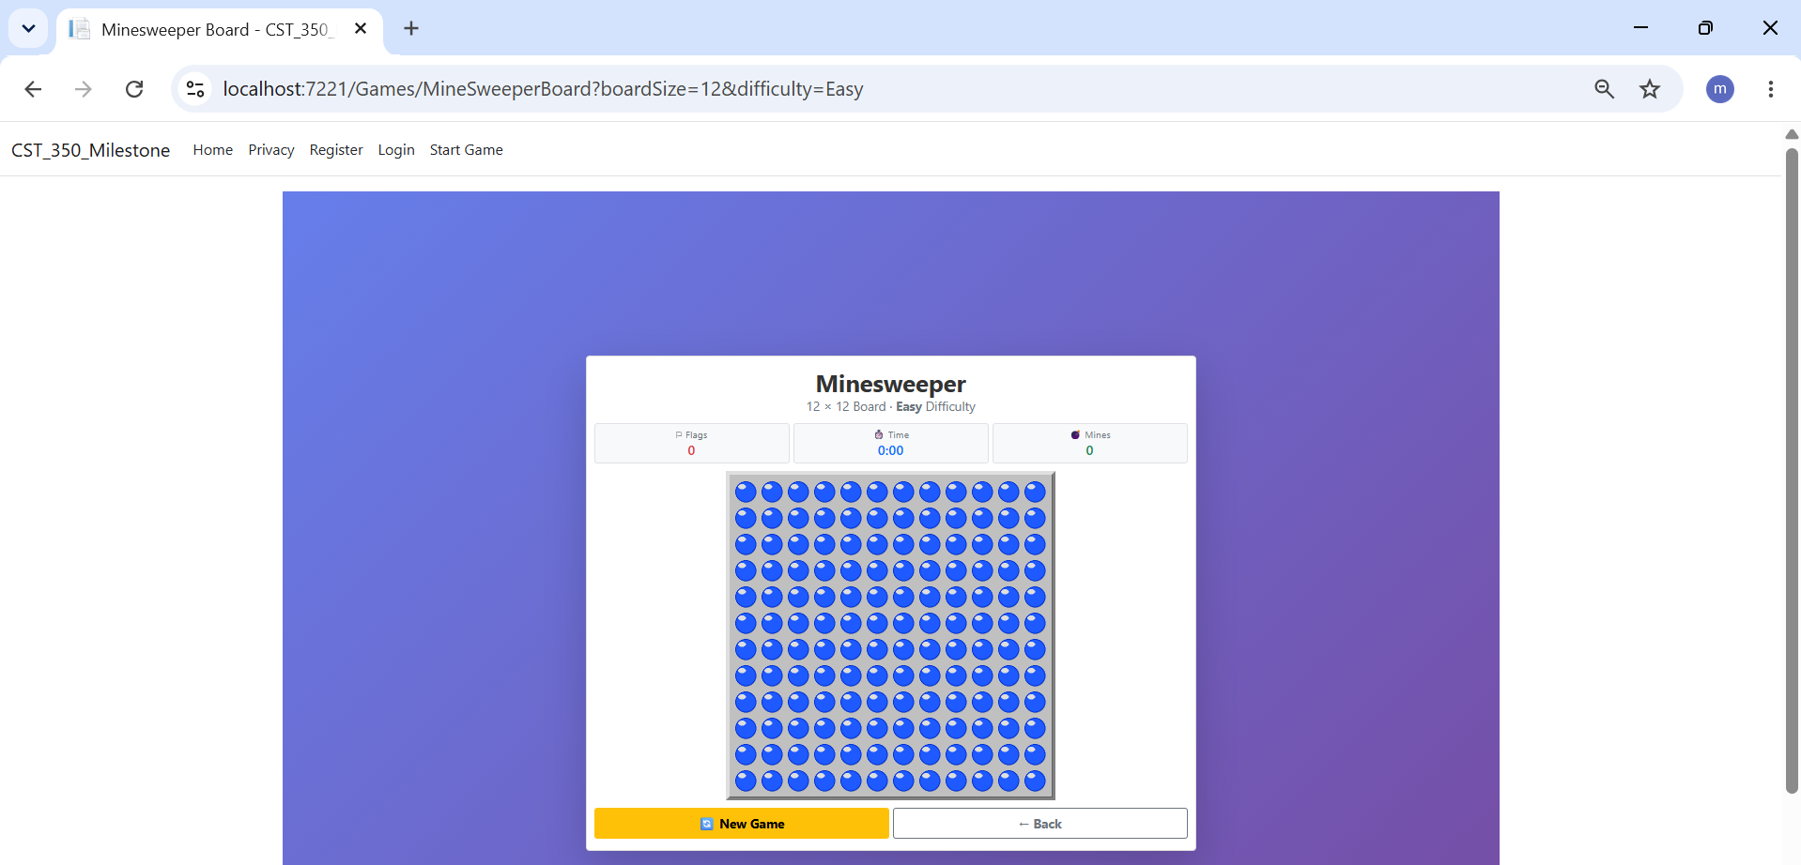
Figure 7. MineSweeper game board generated dynamically for a 12×12 board.

Session Management

We continued using session management from Milestone 1 to control access to the game. Before users can access the Start Game page or the MineSweeper board, the application checks whether they are logged in. If they are not authenticated, they are redirected to the Login page.

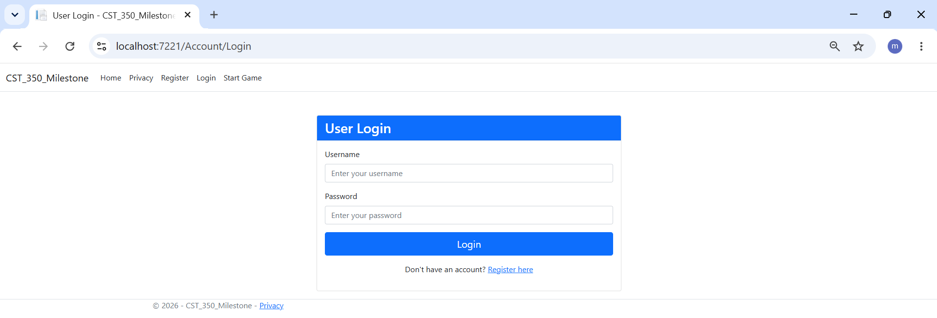
Figure 8. Login page displayed when an unauthenticated user attempts to access the game.

Win and Loss Pages

Win and loss pages were created to display the outcome of the game. These pages are displayed after the backend game logic determines whether the player has won or lost. Each page includes navigation options that allow the user to start a new game or return to the home page.

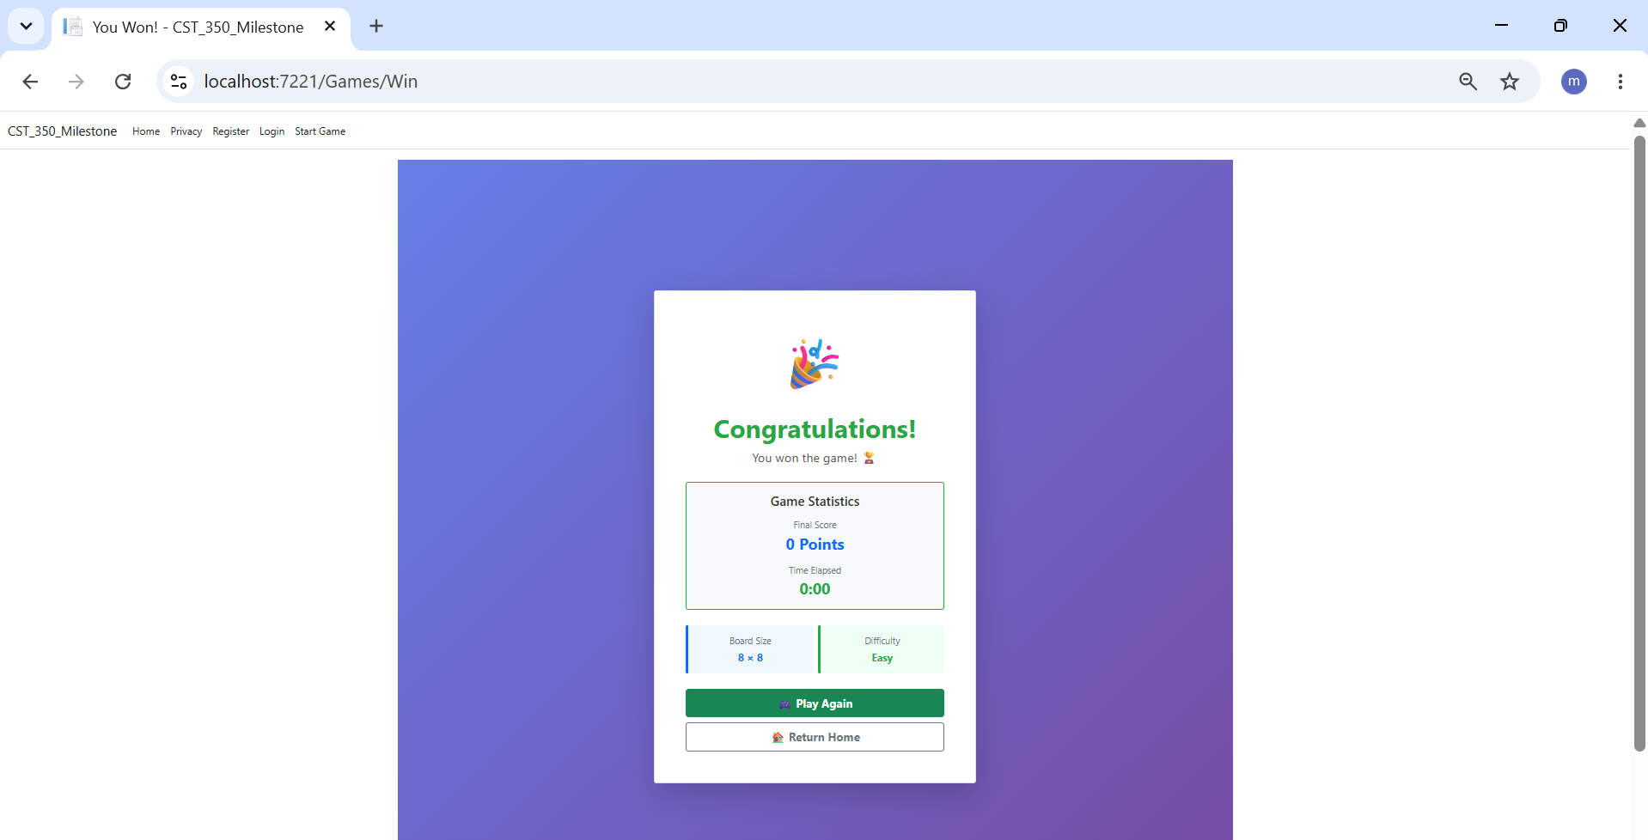
Figure 9. Placeholder Win page displayed after successfully completing the game.

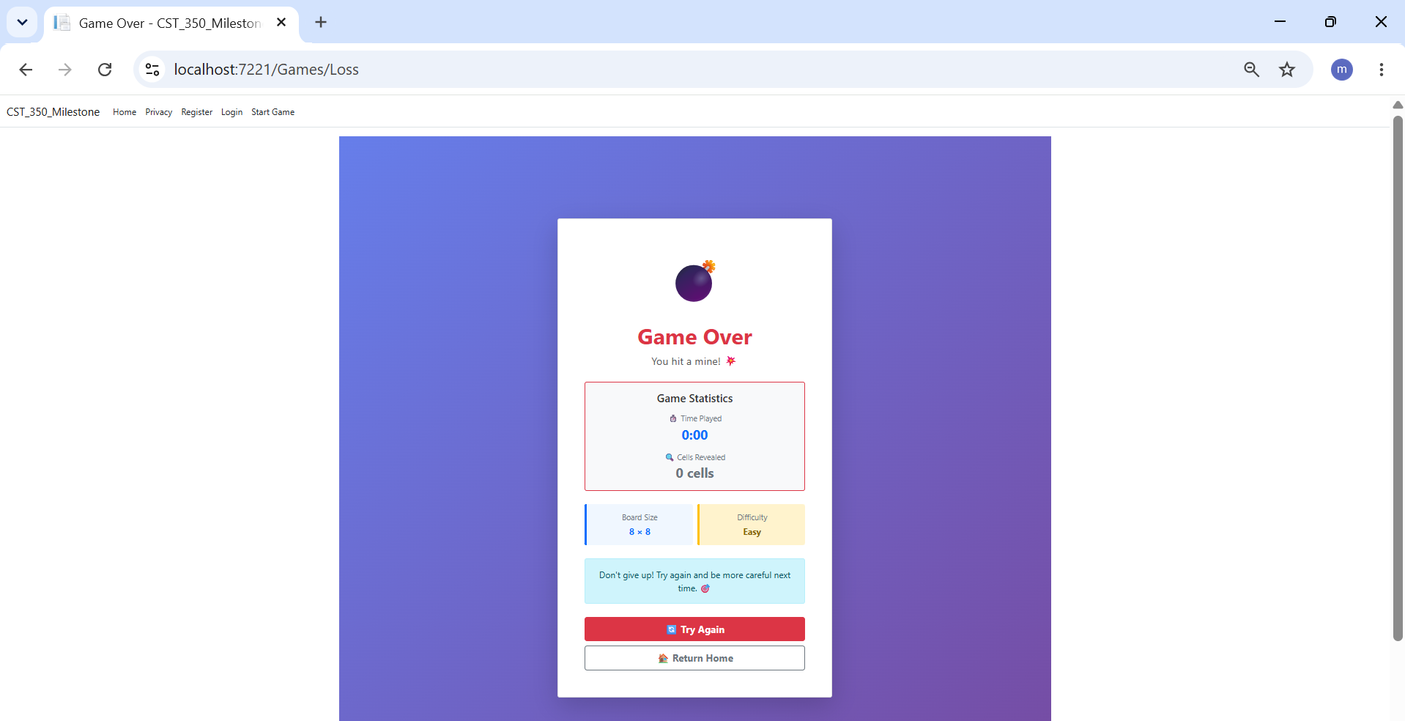
Figure 10. Placeholder Loss page displayed after selecting a mine.

MVC Implementation

The project follows the MVC design pattern used throughout the CST-350 activities. Models are used to store and validate application data, Views provide the user interface, and Controllers process user requests and control the application flow. The MineSweeper game board is rendered by passing a collection of CellModel objects from the controller to the Razor view, following the same approach demonstrated in the ButtonGrid activity.

Backend Integration

The frontend was integrated with the backend game logic to provide a complete Minesweeper experience. The backend handles board creation, mine placement, cell selection, score calculation, and win/loss detection, while the frontend displays the game state using Razor Views. This separation follows the MVC design pattern used throughout the course.

Conclusion

Milestone 2 allowed us to apply the ASP.NET Core MVC concepts learned throughout the course by combining the user interface with the backend game logic. The completed application allows users to configure a game, play Minesweeper, and view the game results through a responsive web interface.

